Linden Primary Short Stay Autumn Homework Grid

1.Make and design a fantasy creature- don’t forget to give it a name!  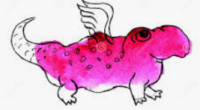 | 7.Go swimming with your family   | 13. Can you make a structure such as the Eiffel Tower out of marshmallows and spaghetti or the learning tower of Pisa? | 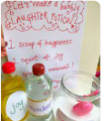  19. Make a kindness potion. What ingredients would you use?
2.Complete a fact file based on something you have found interesting in your topic work.  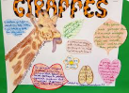 | 8. Do something kind for someone else. What could you do to help around your home?   | 14.Take rubbings of patterns of things around you- tree bark is a good one to start with!  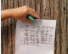 | 20. Draw a picture of who you want to be when you are older.  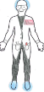
3.Write a letter to the King to tell him all about Telford   | 9.Can you make a bridge that can hold the weight of a can of beans?  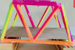 | 15. Sing a song while gargling water! What song did you pick an why?   | 21. Draw or paint a picture of something special to you on a pebble.  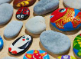
4.Play a board game and have lots of fun!  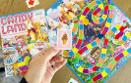 | 10.Go to a park. Which park did you go to? Which is your favourite park?   | 16.Can you change the colours of the petals on a flower?   | 22. Create a poppy out egg cartons.  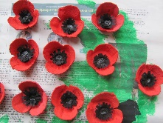  Challenge: Create a poppy wreath.
5.Build a den with natural materials.  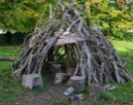 | 11.Make a self portrait out of natural materials in your garden or local area  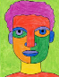 | 17.Read a book and write a review telling others why it’s a good book to read.   | 23. How does your family are recycle? Can you suggest other things they could?  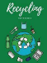
6.Write a recipe for your favourite food  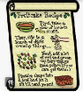 | 12. What songs would a family member consider ‘a classic’? Who performed the song?   | 18. Can you make a volcano?  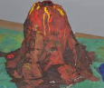 | 24. Make a cake with a grown up.  

