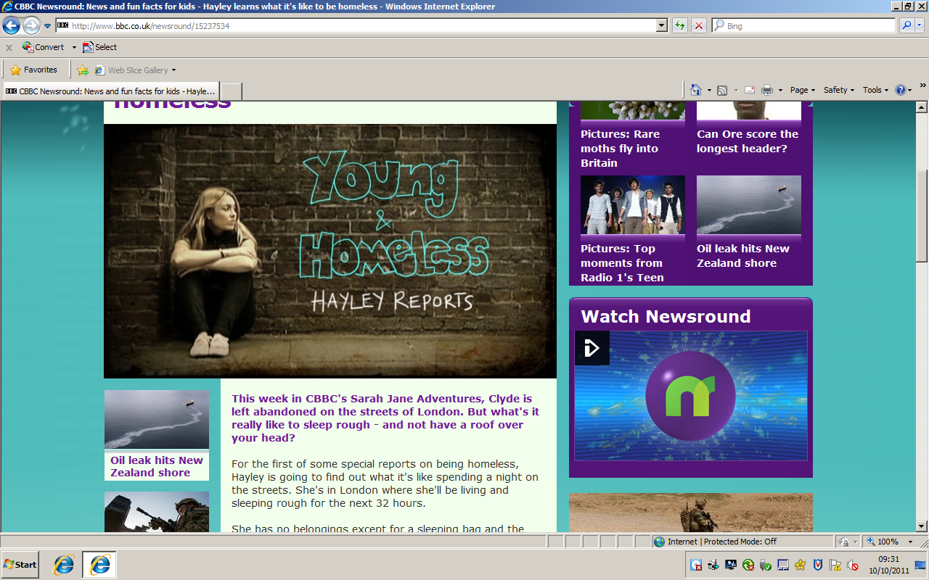
Clyde is left abandoned on the streets of London. But what is it really like to sleep rough – and not have a roof over your head?
For the first of some special reports on being homeless, Hayley is going to find out what I’s like spending a night on the street. She’s in London where she’ll be living and sleeping rough for the next 32 hours.
She has no belongings except for a sleeping bag and the clothes she is wearing.
The charity Shelter says that around 80,000 young people are homeless in the UK. This means they have no permanent home of their own.
Hayley’s going to get a snapshot of what life is like for these people and meet some of them along the way.
She’s currently two hours in and it already feels very different to her average morning. The streets were deserted at 6am, but now people have started their journeys to work.
She says: “It’s just got busy on the streets of London. Just had to use the public toilet – I’ll have to get used to that for the next 30 hours.”
We’ll be keeping you updated on Hayley’s experience throughout the day.

QUESTIONS TO ANSWER: Read Hayley’s report above ‘Young and Homeless’ and answer the following questions.
- The article begins with this sentence: ‘But what is it really like to sleep rough – and not have a roof over your head?’ What is the effect of starting the article with a question?
ANSWER:
By starting the article with a question, the writer makes the reader………………………………………………………………………………………………………………………………………………………………………………………………………………………………………………………………………………………………………………………………………………………………………………………………………………………………………………………………………………………………
- What is Hayley’s reason for carrying out the report Find two correct answers from the article.
ANSWER:
- Hayley is carrying out the report so that…………………………………………………………………………………………………………………………………………………………………………………………………………………………………………………………………………………………………………………………………………………………
- ………………………………………………………………………………………………………………………………………………………………………………………………………………………………………………………………………………………………………………………………………………………………
- Look back through the article and find the evidence for each of the following points:
- She will not have anywhere to sleep. For example, it stays in the text, “…………………………………………………………………………………………………………………………………………………………………………………………………………………………………………………………………………………………………………………………………………………………”
- Hayley will not have any things with her apart from the basics. For example it says in the text, “…………………………………………………………………………………………………………………………………………………………………………………………………………………………………………………………………………………………………………………………………………………………”
- Hayley will have to do things that she does not feel comfortable with for the report. For example, it says in the text, “…………………………………………………………………………………………………………………………………………………………………………………………………………………………………………………………………………………………………………………………………………………………”

