Leaking oil has reached the shore in New Zealand.
Oil leaking from a stranded ship has reached the shore in New Zealand.
The container ship started leaking when it hit a reef in the Bay of Plenty last Wednesday.
The area is one of the country's most popular tourist spots and rescue teams are racing to get the oil off the ship before more escapes.
The spill has left a three mile oil slick and it's already harmed some Little Blue penguins and other sea birds.
Between 20-30 tonnes of oil have leaked so far and two barges are scooping it up.
Authorities say fist-sized balls of oil were found in one of the area's main beaches, which was then closed.
They've now warned people to stay away.
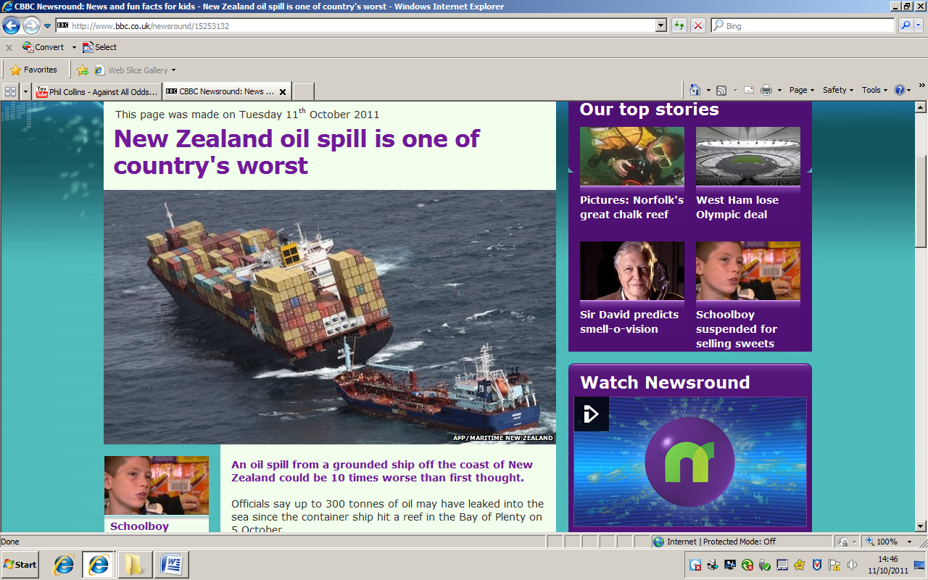

Read the article, ‘Leaking oil has reached the shore in New Zealand. ’ and answer the questions below:
- Look back through the article and find the evidence for each of the following points:
  - The oil will affect a lot of people. For example, it says in the text, “ .... .................................................................................................................................................................................................................................................................... ”
  - A huge effort has been needed to clean up the oil. For example, it says in the text “............................................................................................................. ...................................................................................................................................................................................................................................................................... “
  - The oil is dangerous for people to be near. For example, it says in the text, “........................................................................................................................ ...................................................................................................................................“

- What effect has the oil spill had so far? Find two correct answers from the article.
  - ........................................................................................................................................................................................................................................................................
  - ........................................................................................................................................................................................................................................................................

- How does the article make the oil leak seem like an emergency?
The article makes the oil leak seem like an emergency by............................................
......................................................................................................................................................
For example, it says in the text, “......................................................................................”
This makes the reader feel...................................................................................................
......................................................................................................................................................
The word “........................................” is effective because.................................................
.......................................................................................................................................................
.......................................................................................................................................................

